certificate 1:
https://infyspringboard.onwingspan.com/web/en/app/toc/lex_auth_014218482113093632326/overview
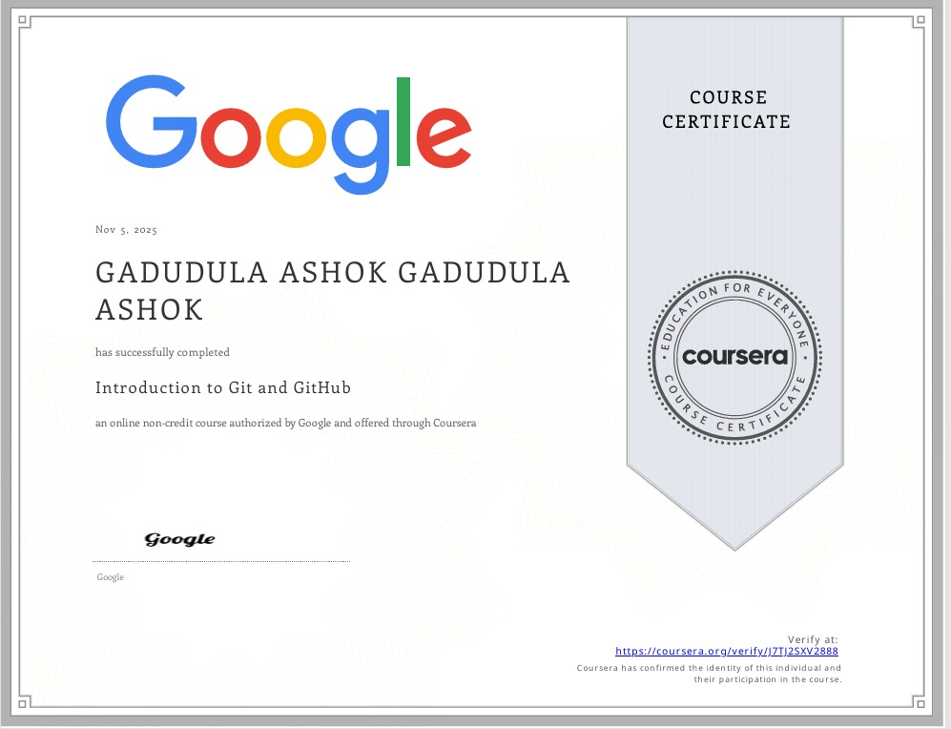

Certificate 2:
https://infyspringboard.onwingspan.com/web/en/app/toc/lex_auth_013719953643773952304_shared/overview


Certificate 3:
https://infyspringboard.onwingspan.com/web/en/app/toc/lex_auth_013749091701841920319_shared/overview


Certificate 4:
https://infyspringboard.onwingspan.com/web/en/app/toc/lex_auth_014157683688415232146/overview


Certificate 5:
https://infyspringboard.onwingspan.com/web/en/app/toc/lex_auth_014157698985598976246/overview


